# **Auth JWT**

## What is JWT (Json Web Token)?

JSON Web Token (JWT) is a token based authentication between two servers. In this a JSON object that is digitally signed using JSON Web Signature (JWS) and encrypted using JSON Web Encryption (JWE).

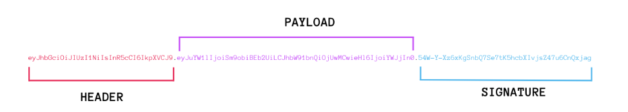

## Authentication sequence for JWT

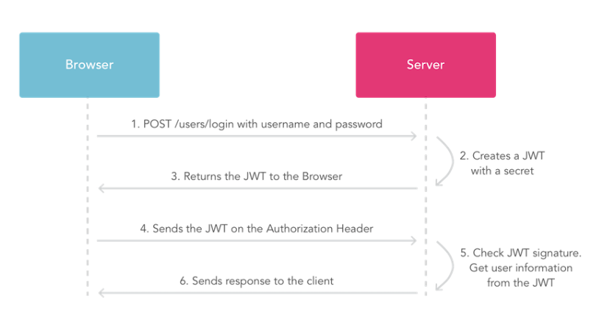

## What is Auth JWT?

Auth JWT is a helper to achieve JWT authentication in ASP.Net Core applications in an easy and flexible way.

## Hashing Algorithms Used

* SHA1
* SHA256
* SHA384
* SHA512

## Components of Auth JWT

* **TokenRequestModel** is a class which contain properties for Auth JWT payload.
  + [Note: All properties are not mandatory.]
* ***Issuer***
* ***ExpiryInSeconds***
* ***UserId***
* ***User***
* ***Role***
* ***Audience***
* ***JwtId***
* ***Subject***
* ***CustomProperty***
* **AlgorithmType** is constant class to get the algorithm details
* ***SHA1***
* ***SHA256***
* ***SHA384***
* ***SHA512***
* **JWTModule** is a class which contains all the interfaces for Auth JWT.
* ***CreateToken(<TokenRequestModel>, <secrect>, <AlgoritmType>)*** -> Function creates the token
* ***VerifyToken(<token>, <secrect>, <ValidateModel Optional>)*** -> Function verifies the token.
* **TokenResponseModel** is a class which contains the Status and Content of the Auth JWT response.
* ***Status***
* ***Content***
* **ValidateModel** is a class which contain properties to be verified in the VerifyToken() function.
  + [Note: All properties should match the **TokenRequestModel**.]
* ***Issuer***
* ***UserId***
* ***User***
* ***Role***
* ***Audience***
* ***JwtId***
* ***Subject***
* ***CustomProperty***

## Configuration of Auth.JWT

### Step 1:

Add the service to the **ConfigureServices(IServiceCollection services)** function.

***services.AddAuthService();***

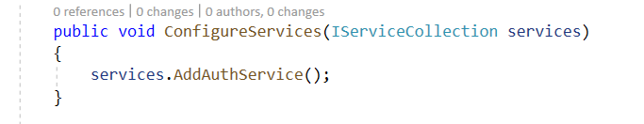

### Step 3

Implement Constructor injection in the required classes, to get the object of Auth.JWT.

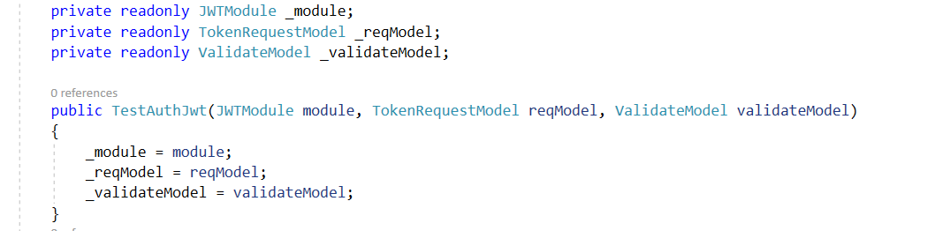

## Sample Code Snippet

In the below code, I have used Auth.JWT to create and validate the token in a simple class for better understanding.

|  |
| --- |
| class TestAuthJwt  {  private readonly JWTModule _module;  private readonly TokenRequestModel _reqModel;  private readonly ValidateModel _validateModel;  public TestAuthJwt(JWTModule module, TokenRequestModel reqModel, ValidateModel validateModel)  {  _module = module;  _reqModel = reqModel;  _validateModel = validateModel;  }  public void Execute()  {  string secrect = "F4760D";  _reqModel.Issuer = "authjwt_team";  _reqModel.ExpiryInSeconds = "1000";  _reqModel.UserId = "U1324322";  _reqModel.User = "sambeet";  _reqModel.Role = "admin";  _reqModel.Audience = "authjwt_app";  _reqModel.JwtId = "J4433421";  _reqModel.Subject = "authjwt_subject";  _reqModel.CustomProperty.Add("CustomField1","auth_custom1");  _reqModel.CustomProperty.Add("CustomField2", "auth_custom2");  var result = _module.CreateToken(_reqModel, secrect, AlgorithmType.SHA256);  Console.WriteLine("************* Create Token Result***************");  Console.WriteLine(Newtonsoft.Json.JsonConvert.SerializeObject(result));  _validateModel.Issuer = "authjwt_team";  _validateModel.UserId = "U1324322";  _validateModel.User = "sambeet";  _validateModel.Role = "admin";  _validateModel.Audience = "authjwt_app";  _validateModel.JwtId = "J4433421";  _validateModel.Subject = "authjwt_subject";  _validateModel.CustomProperty.Add("CustomField1", "auth_custom1");  _validateModel.CustomProperty.Add("CustomField2", "auth_custom2");  var verifyResult = _module.VerifyToken(result.Content, secrect, _validateModel);  Console.WriteLine("************* Verify Token Result***************");  Console.WriteLine(Newtonsoft.Json.JsonConvert.SerializeObject(verifyResult));  Console.ReadKey();  }  } |